1. Configure the Report Server configuration Manager to build reports by following steps
2. Create a Service Account by using account name (Domain\user) and password. Apply these changes by clicking the “Apply” button.

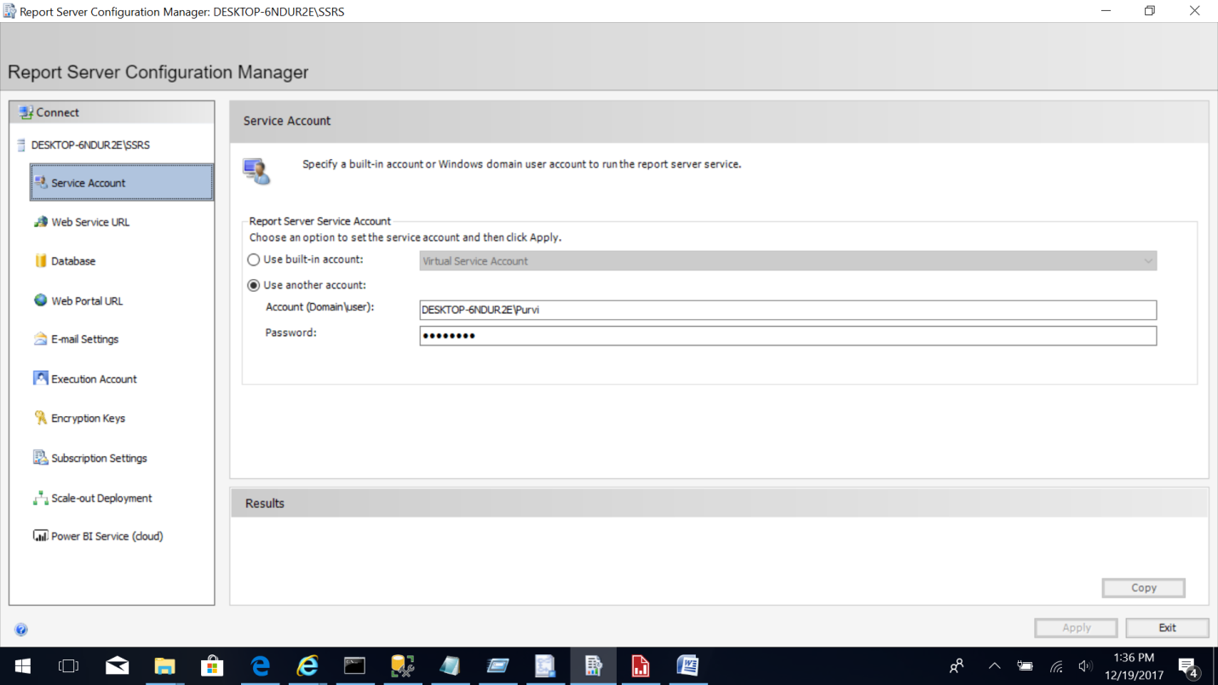

1. Configure the report server as following, with Virtual Directory as “ReportServer” and use the localhost IP Address 127.0.0.1, use TCP Port “80”, HTTPS Certificate as “Not Selected”. Apply these changes by clicking the “Apply” button.

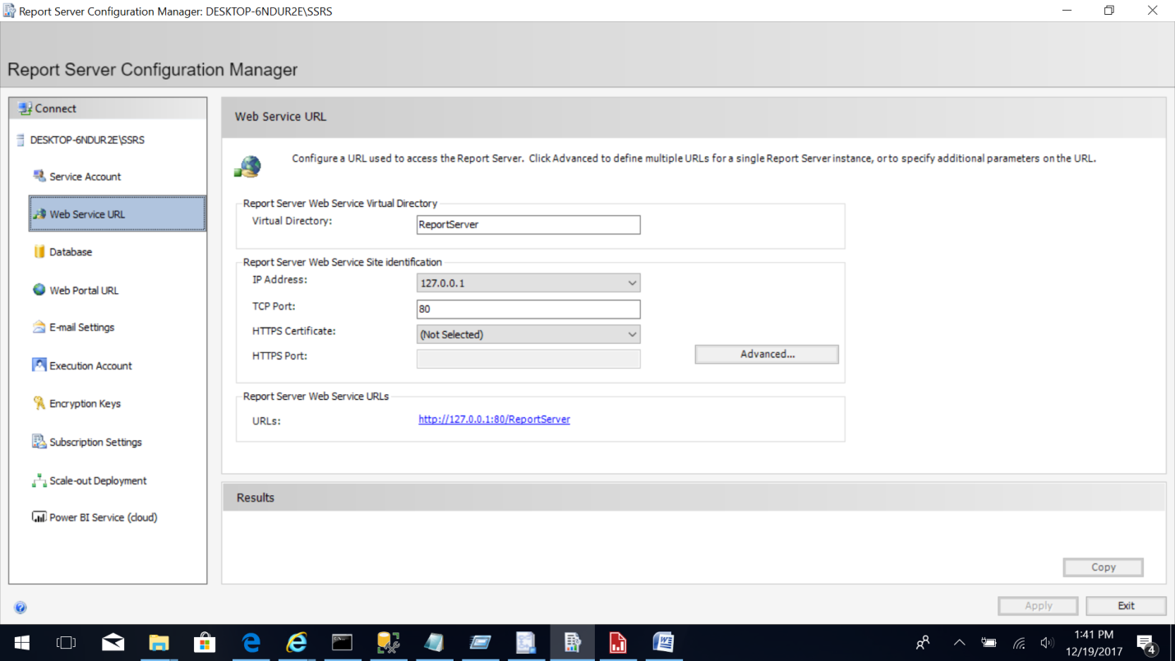

1. Configure the database using the “Database” option on left. Click on “Change Database” button. Select the “Create a new report server database” option then click “Next”.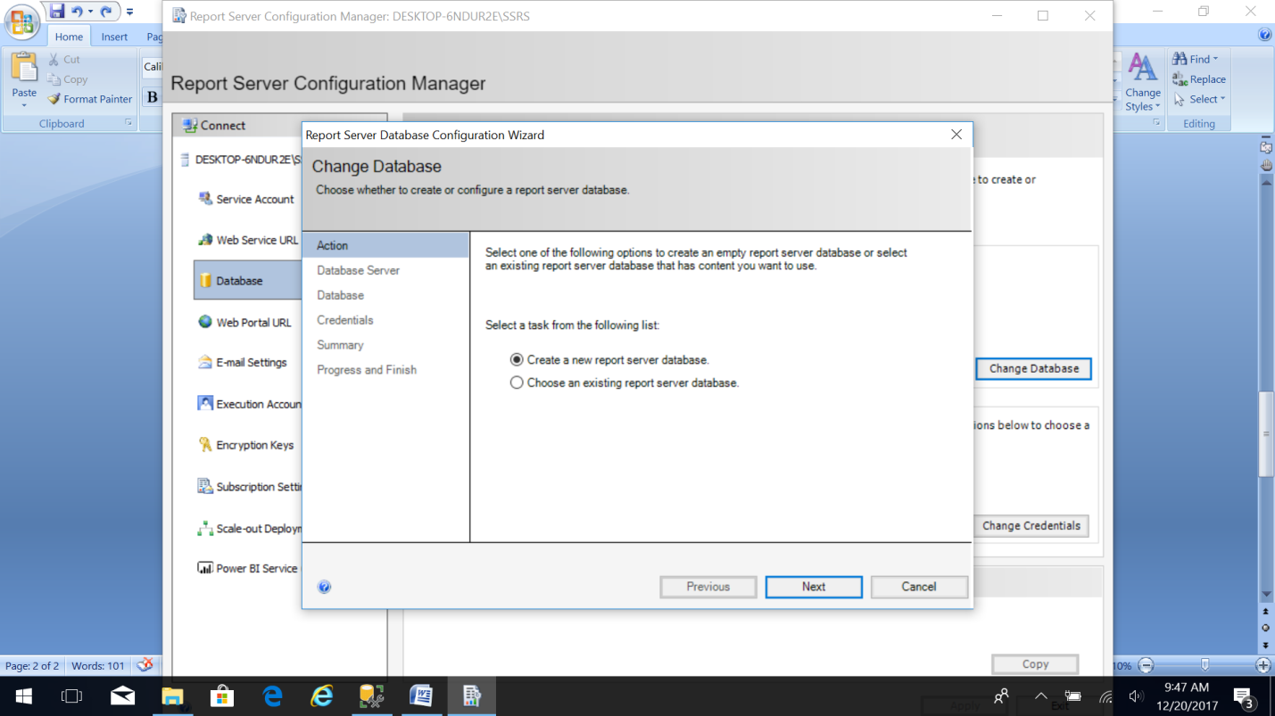
2. Choose the server name and authentication type as “Current User – Integrated Security”. Provide Username and Password. Click “Next”.

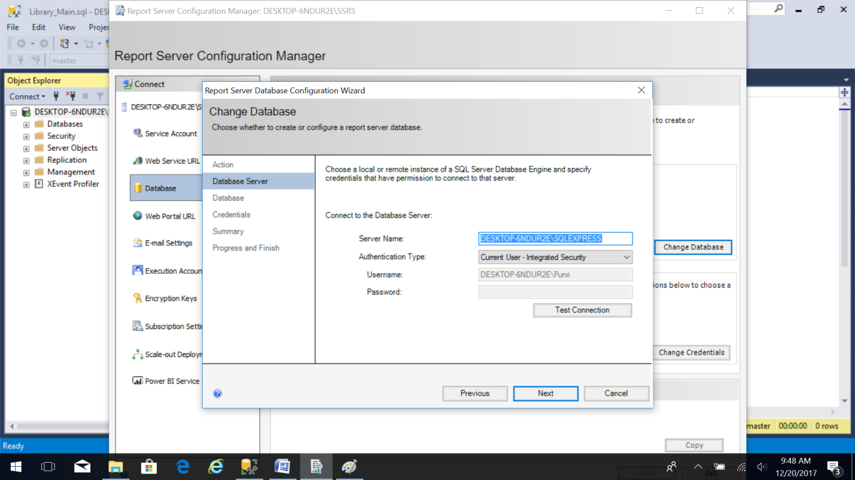

1. Enter the Database name and then click Next. 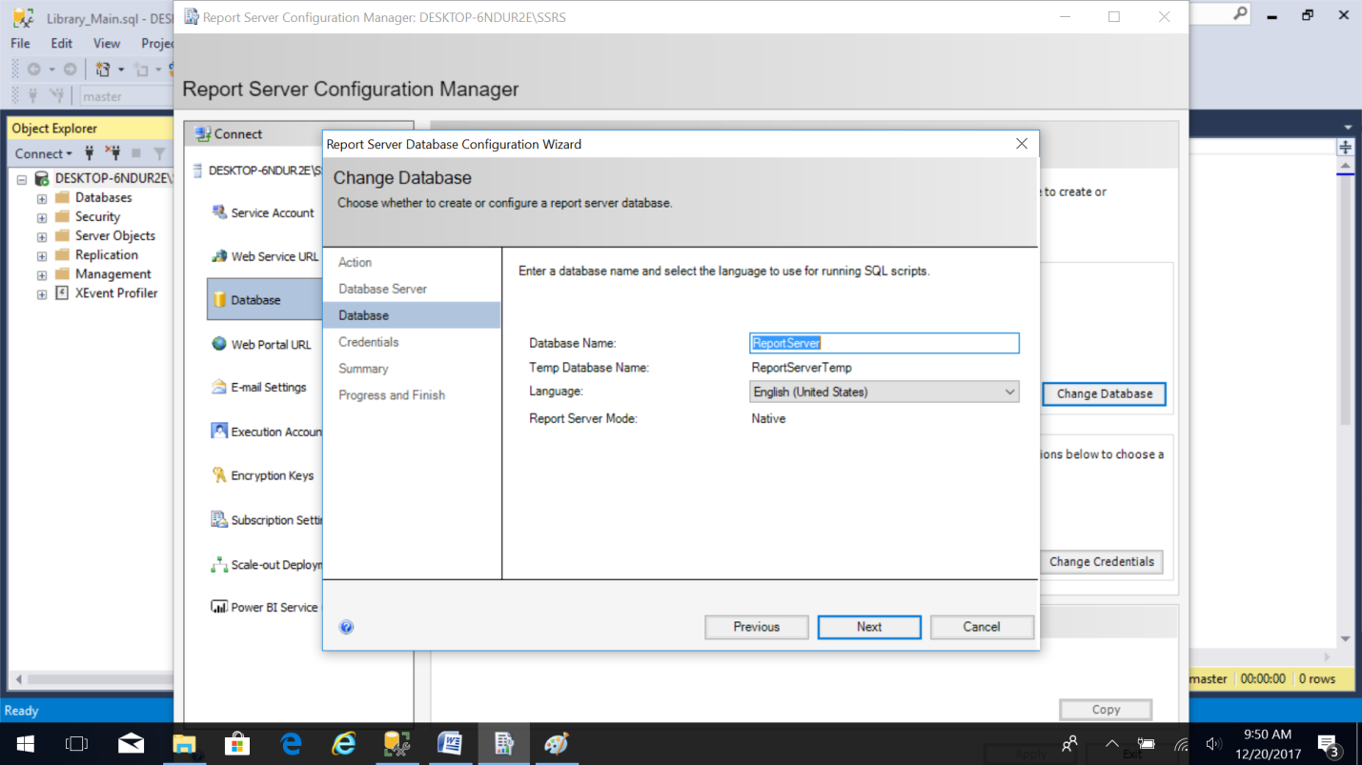
2. Provide the Authentication type as “SQL Server Credentials”. Provide the user name and password. Click “Next”. 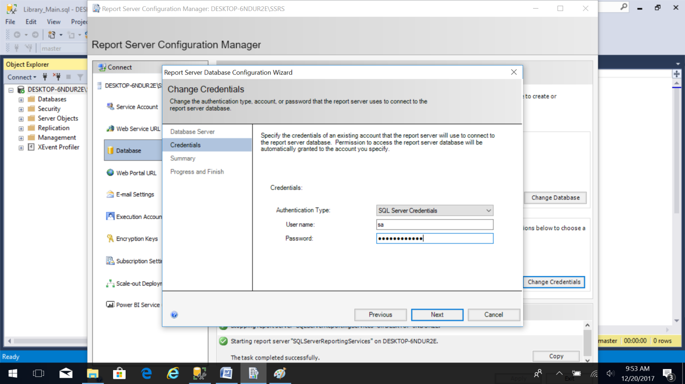
3. Verify the account credentials. Then click “Next”. 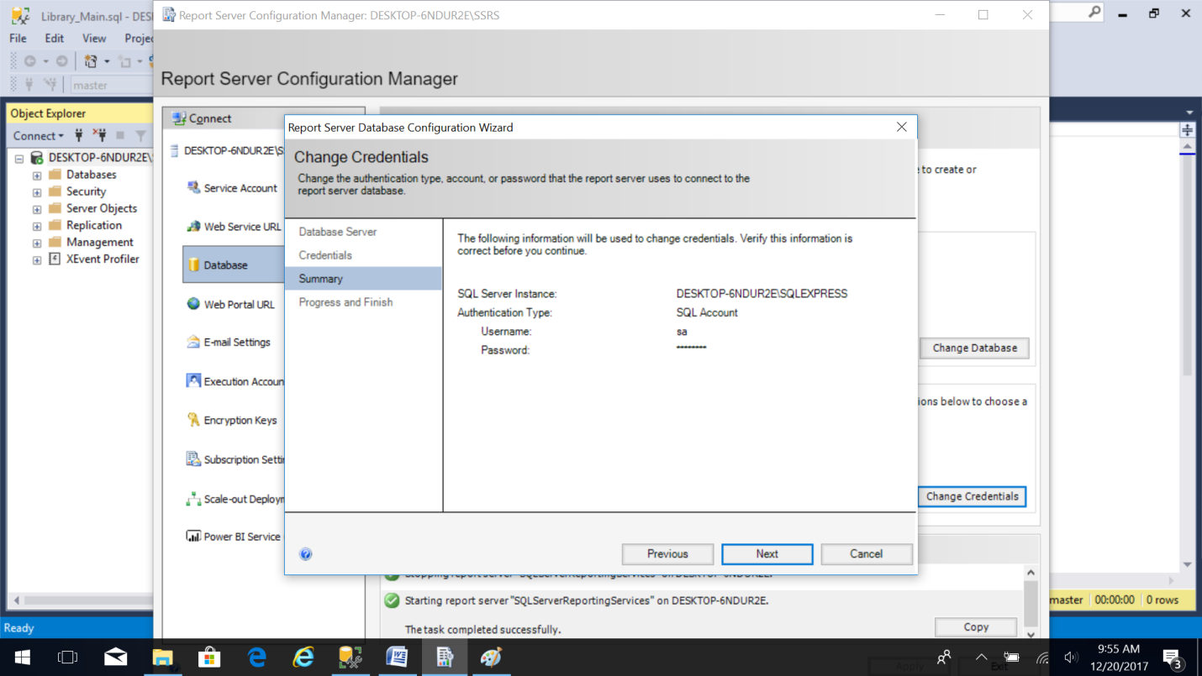
4. Wait for the changes to be applied. Then click the “Finish” button. The report server is restarted with the applied configuration. 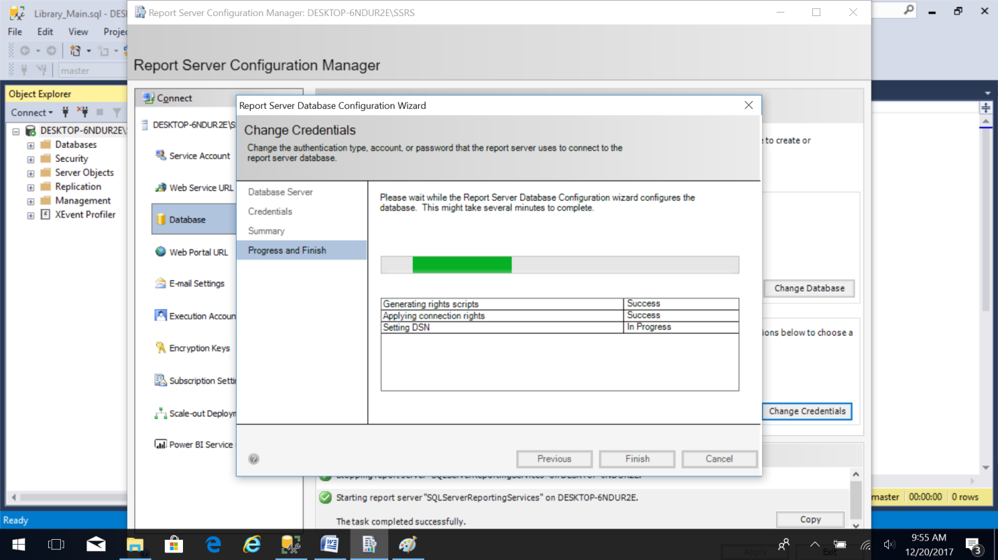
5. Configure the “Web Portal URL” by selecting the option on left. Specify the Virtual Directory and click the “Advanced” button. 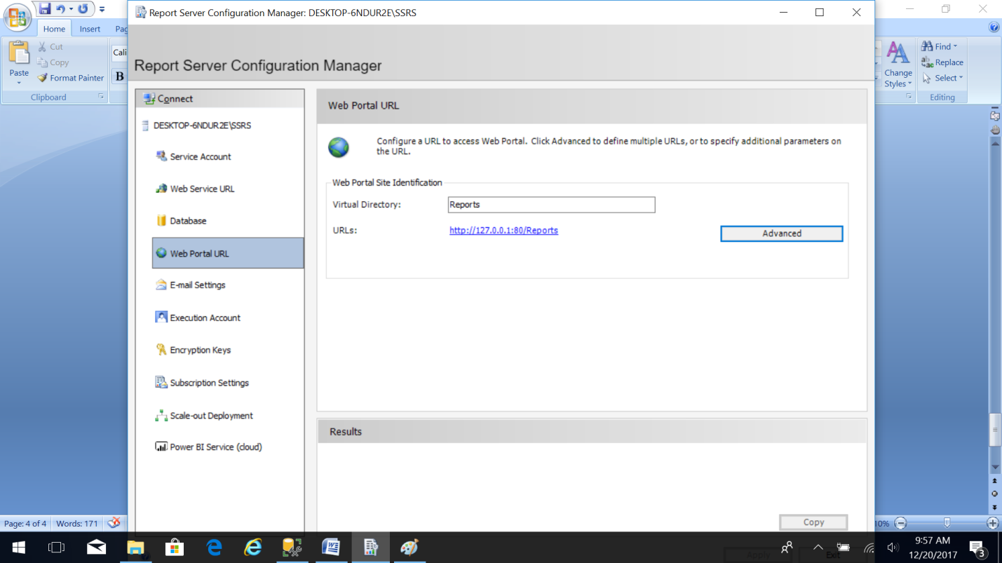
6. In the “Advanced” button select the localhost IP address 127.0.0.1 and TCP port 80. Click the “OK” button. 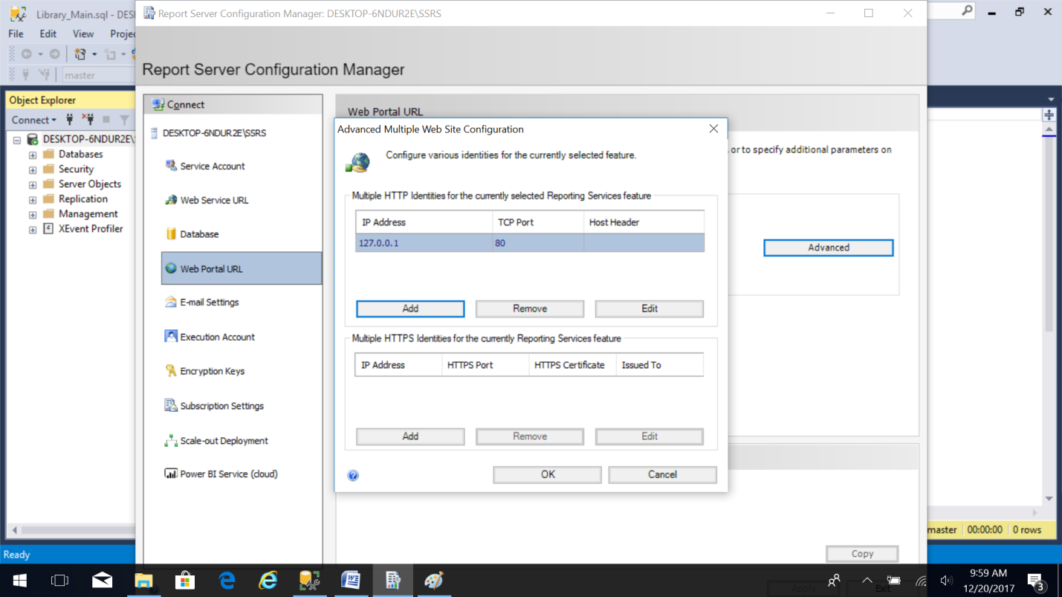
7. SQL Report Server is restarted with the applied configuration. 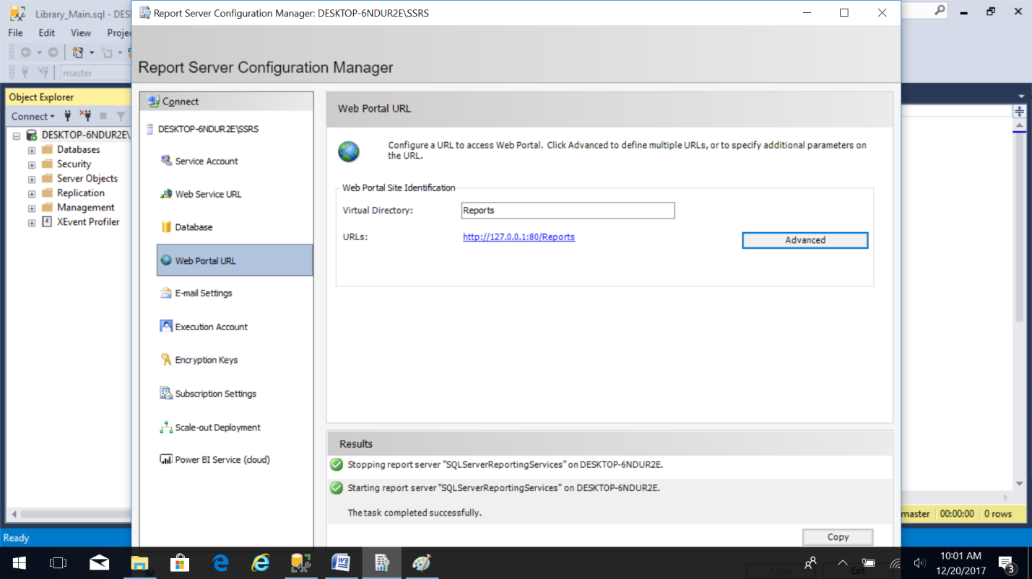
8. Click on the “Web Service URL” option on left. Now click on the Report Server Web Service URL as shown in image below. This opens a new window in web browser. 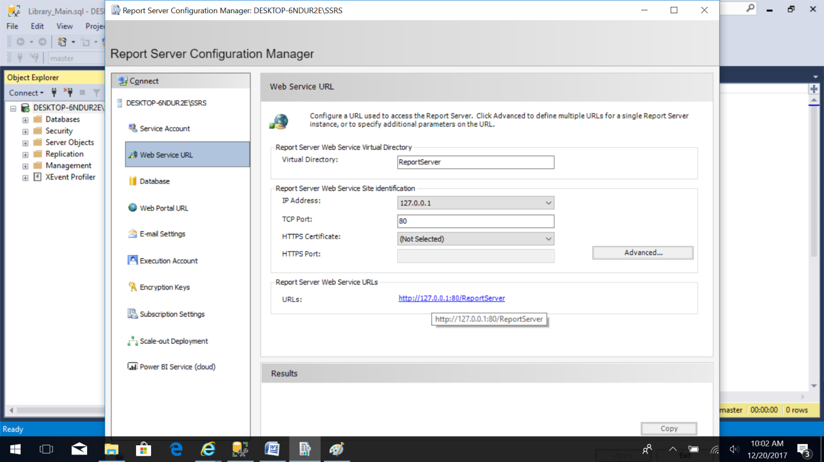
9. Provide the password for authentication. 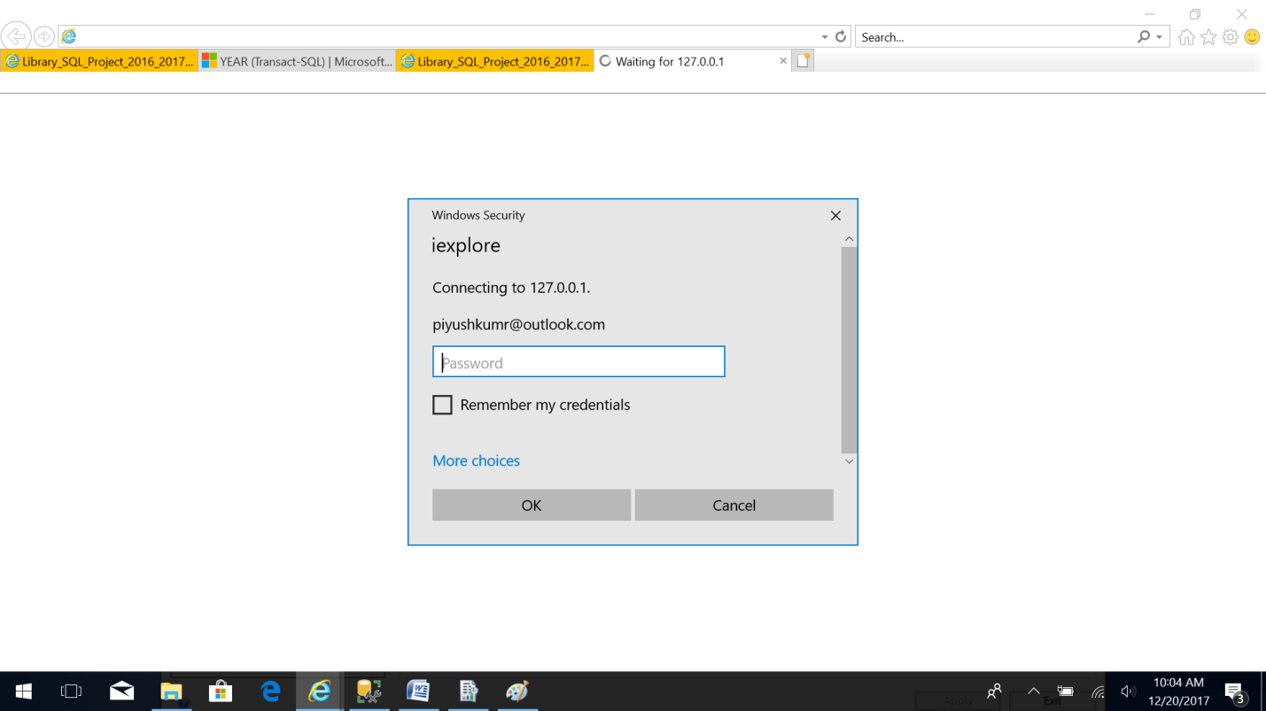
10. This opens a website with a list of published reports. The reports can be prepared with the “Microsoft SQL Server Report Builder” application which can then be published on the Microsoft SQL Report Server for access. In the below snapshot the reports are already published using the Report Builder. 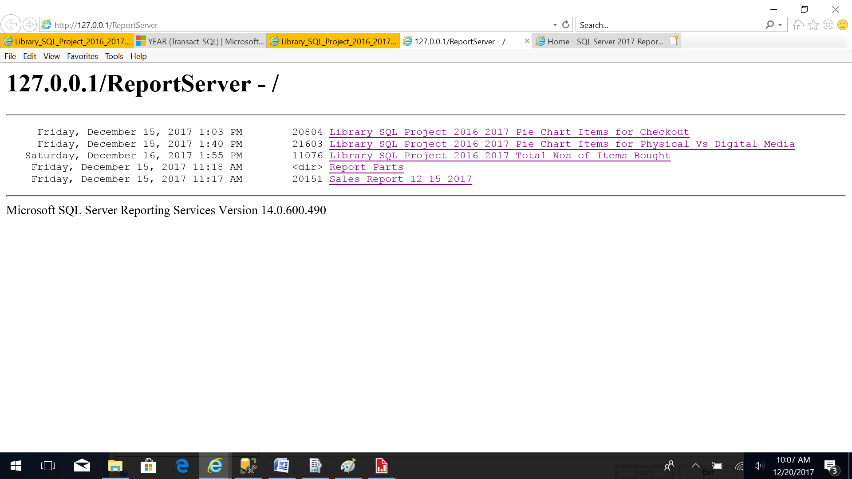
11. To create reports use the Microsoft SQL Server Report Builder application. Provide the report server URL where the reports need to be published. Change the report parts folder name if required. Then click “OK”.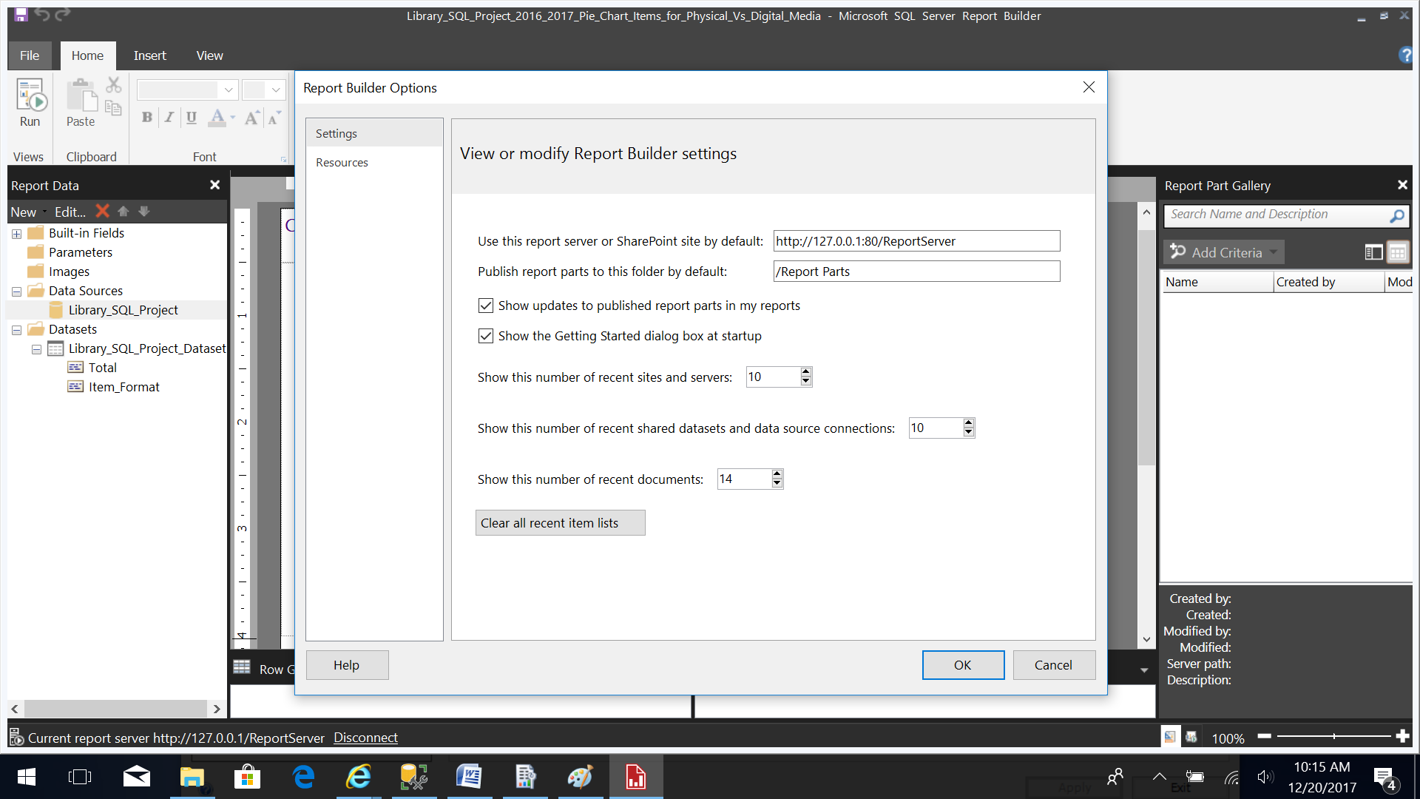
12. The report server needs to be started and running for the Report Builder to access the server. 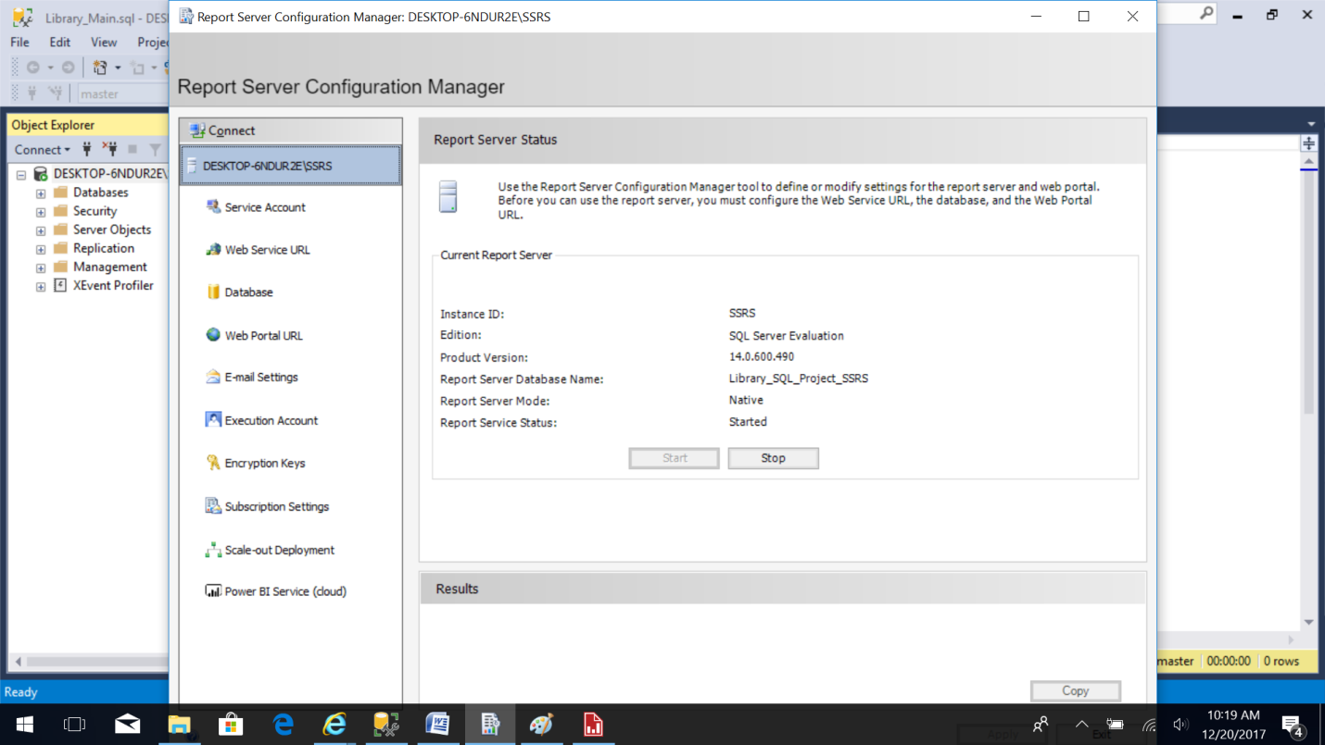
13. Prepare a new report by clicking the “New Report” link. Select “New Report” and “Chart Wizard” option. This option helps you through creating column, line, pie, bar and area charts. 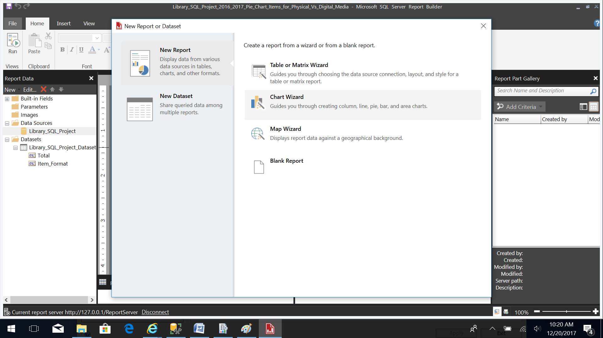
14. To create this new report either select the “existing dataset” or “create a new dataset” option then click “Next”. 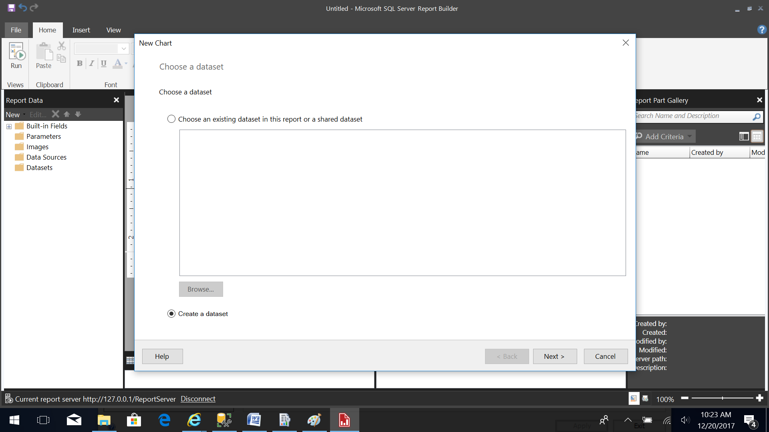
15. Choose a published data source or create a connection with the data source for use only in this report by clicking the “New” button. 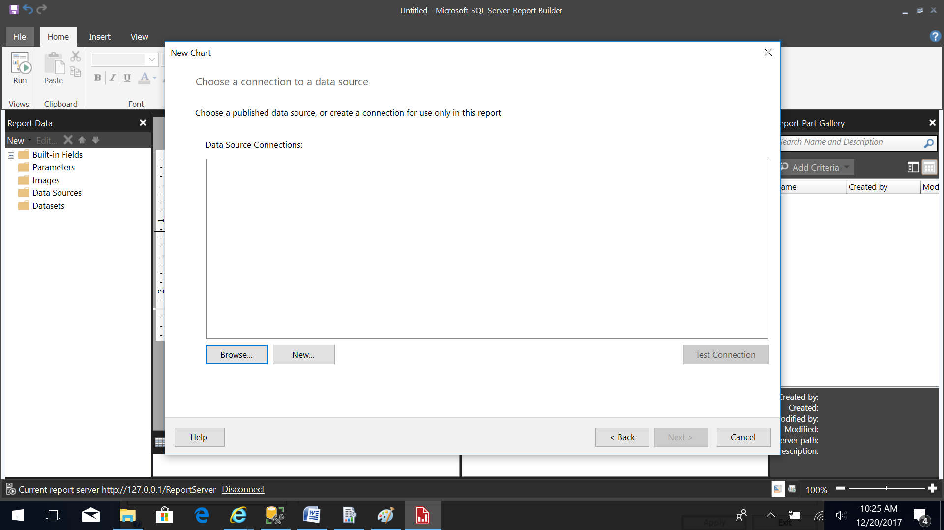
16. Change the name of the SQL Server Data Source as required and Build the Connection String by clicking the “Build” button. 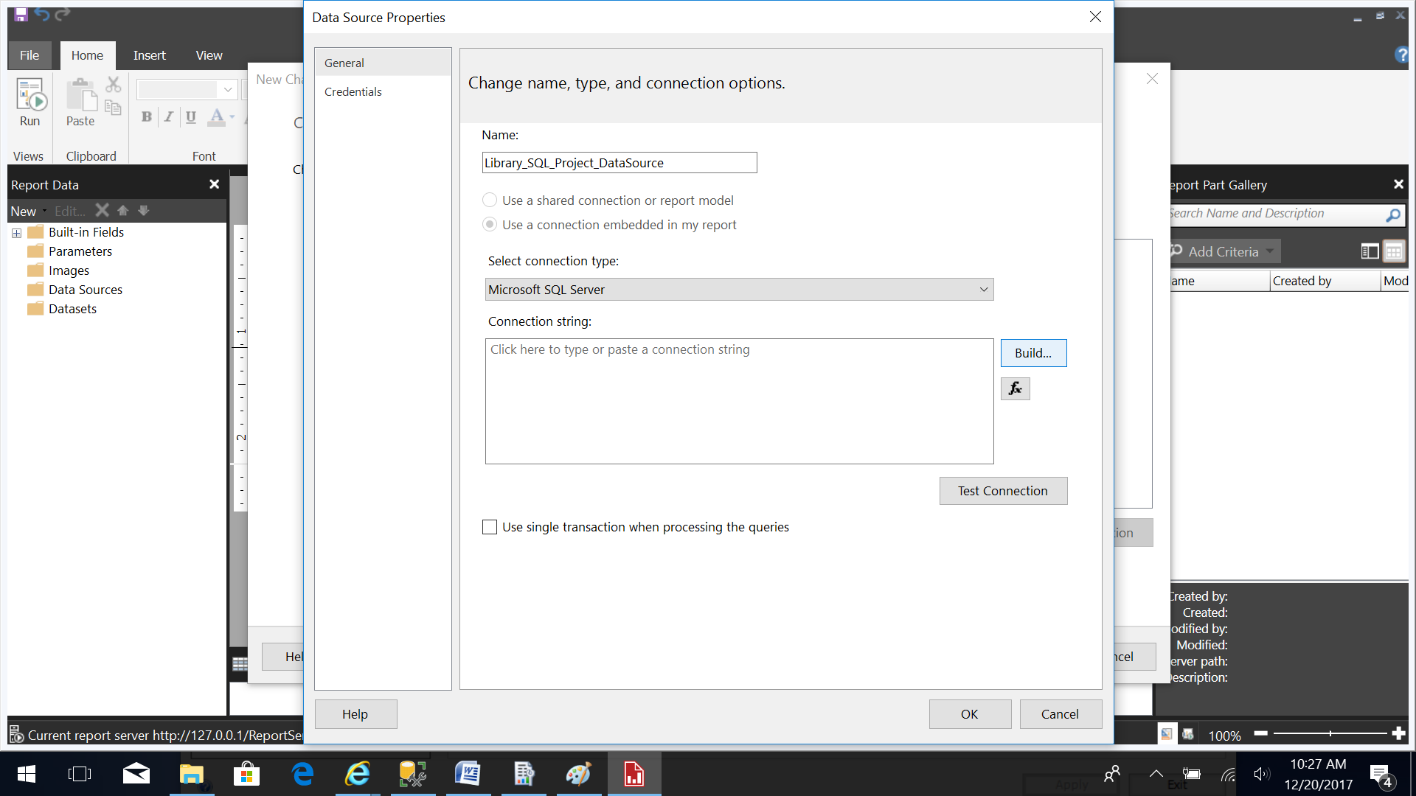
17. Build the connection string by specifying the Server name, log on to the server using “Windows Authentication” and enter the database name. Click on “Test Connection” to check for correct configuration. 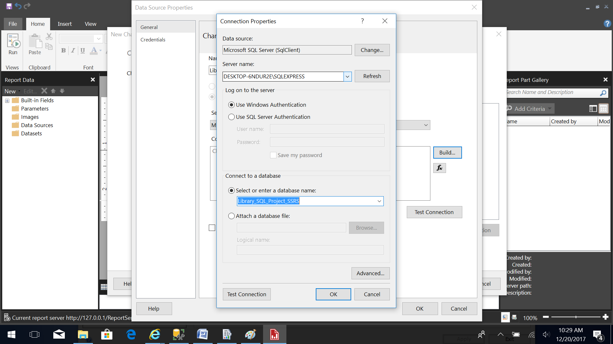
18. The following message should pop-up. Click “OK”. 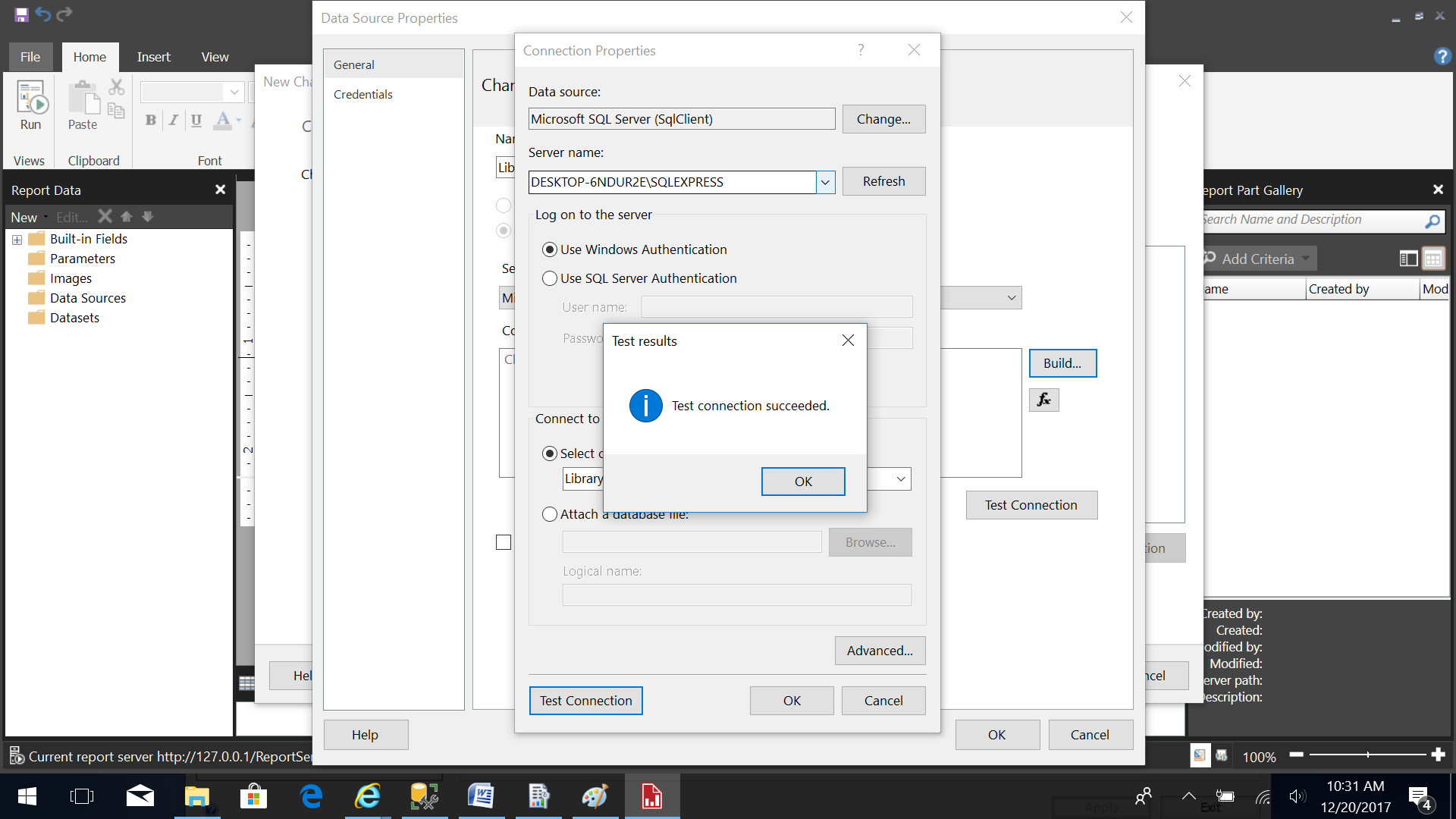
19. Now you should see the connection string. Click “OK”. 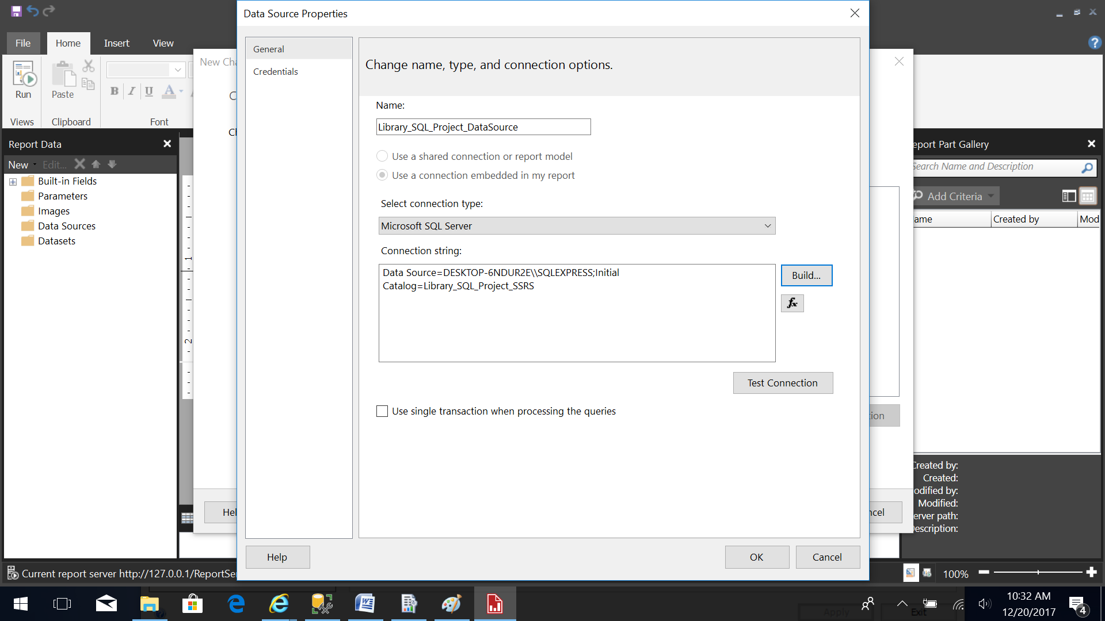
20. Now you should see the data source connection. Click “Next”. 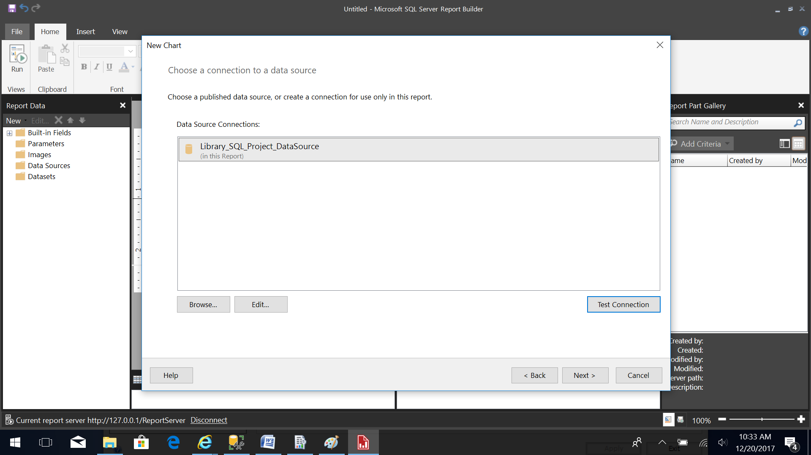
21. Build the query to specify the data you want from the data source. This can be written in text by clicking the “Edit as Text” option. 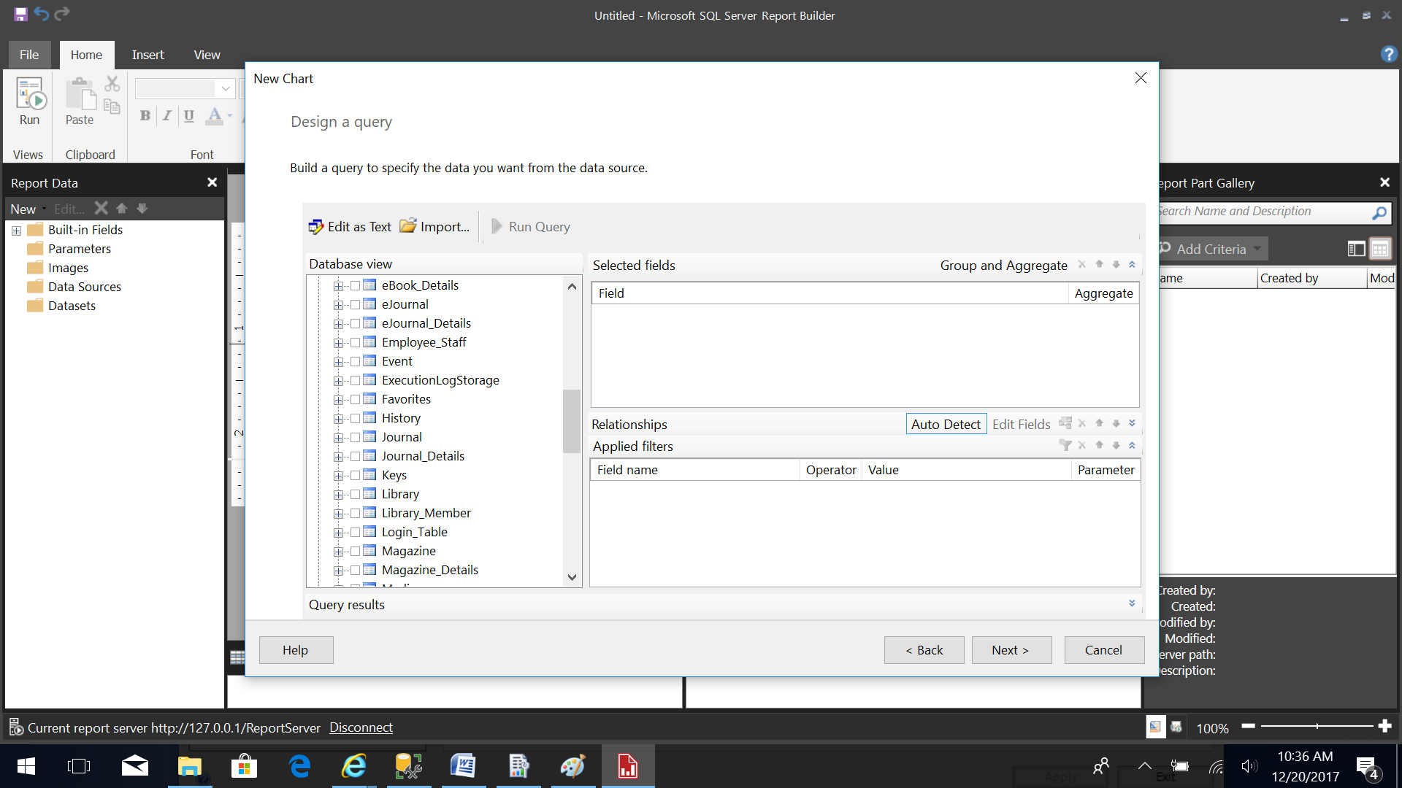
22. Below is an option for specifying the query as text to calculate the total number of Physical Media and Digital Media in the Library using the Library_SQL_Project database. 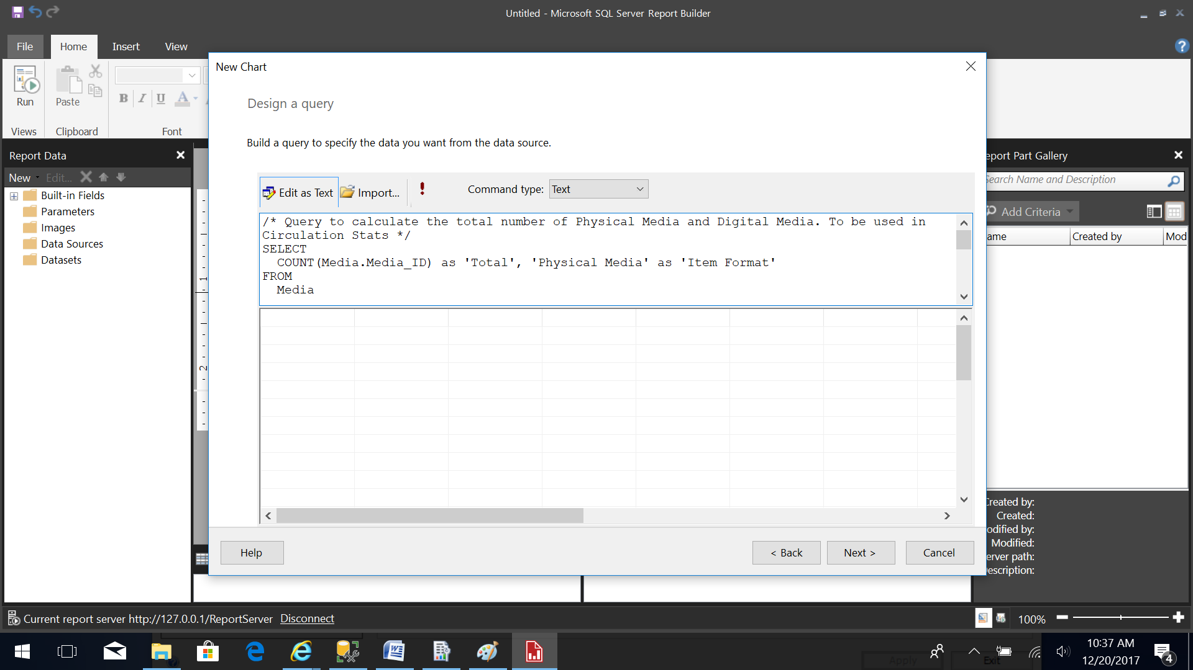
23. Select the type of chart to display your data. Here I have selected pie chart. Then click “Next”. 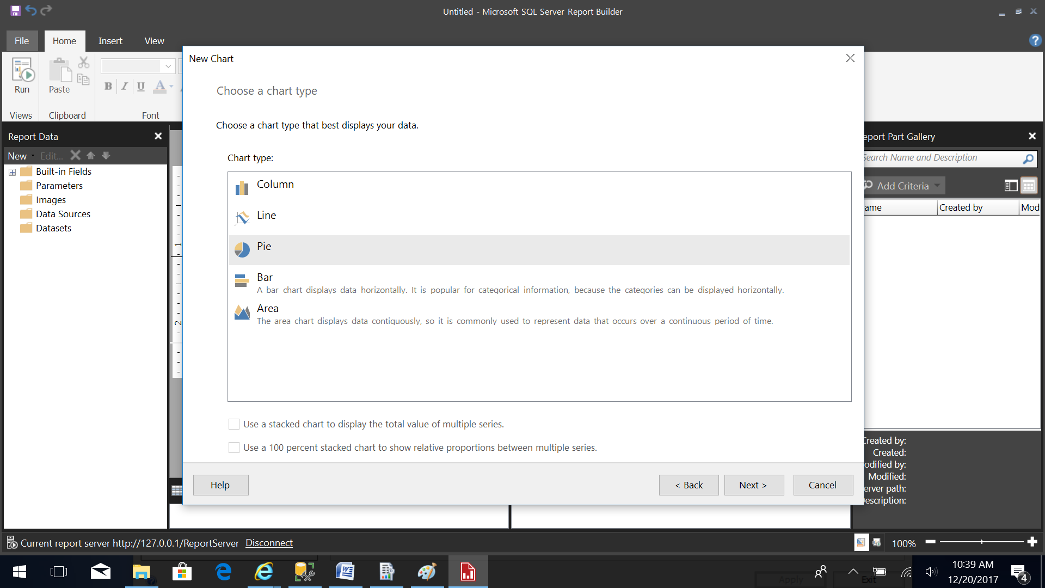
24. Now arrange the chart fields by double clicking on the fields. The fields are automatically added to Values (y-axis) or Categories (x-axis) list corresponding to the field’s data type. 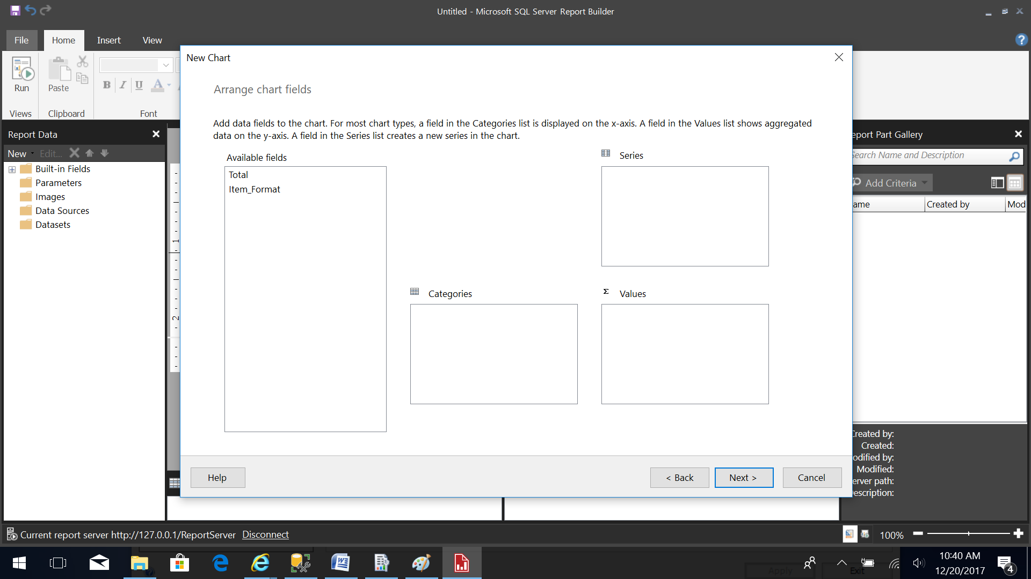
25. The below snapshot shows how the items were arranged in Values and Categories list when double clicked. Then click “Next”.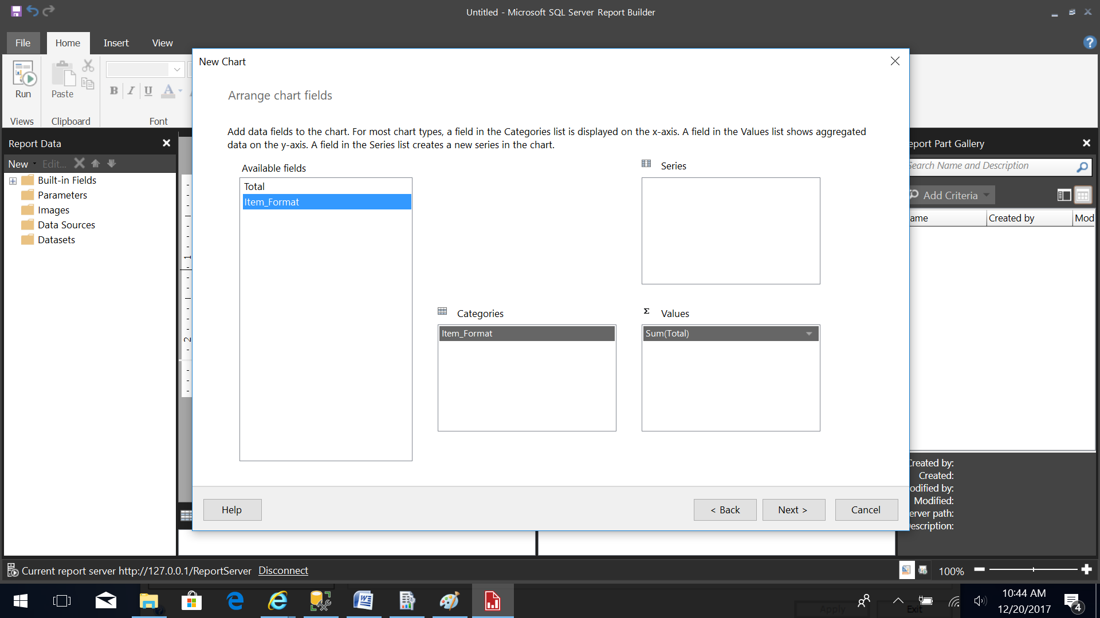
26. A preview is shown for the generated chart. Then click “Finish”. The Chart title and legend are for display purposes only. The actual legend is displayed when the report is run. The chart title can be modified as needed. 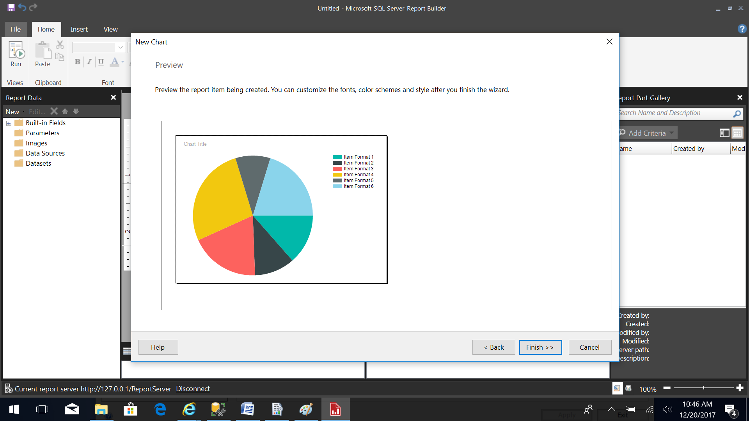
27. Make necessary changes here to add or modify the chart title and report title. 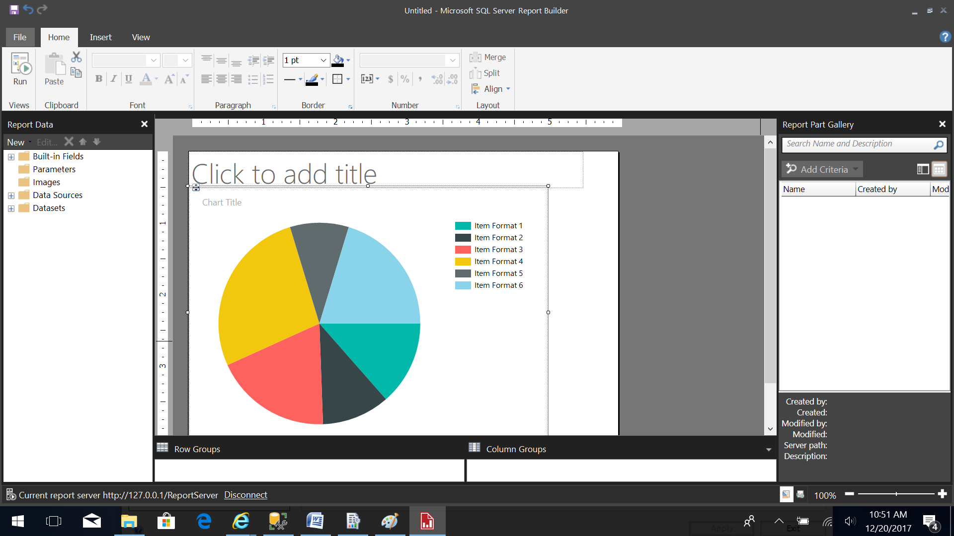

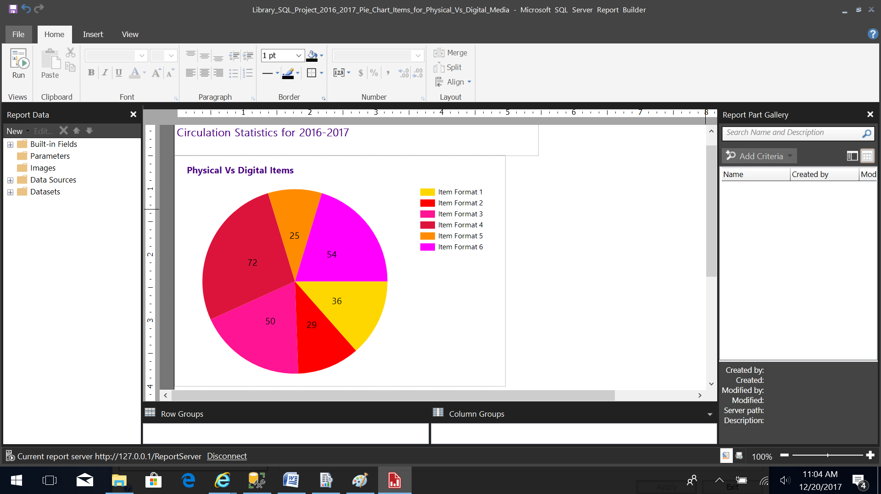

1. In the below chart a sub-report is also added. Sub-report is another report which can be embedded in the current report. Right click to insert an object in this report. Click on sub-report option to create a new sub-report object to be embedded in this report. 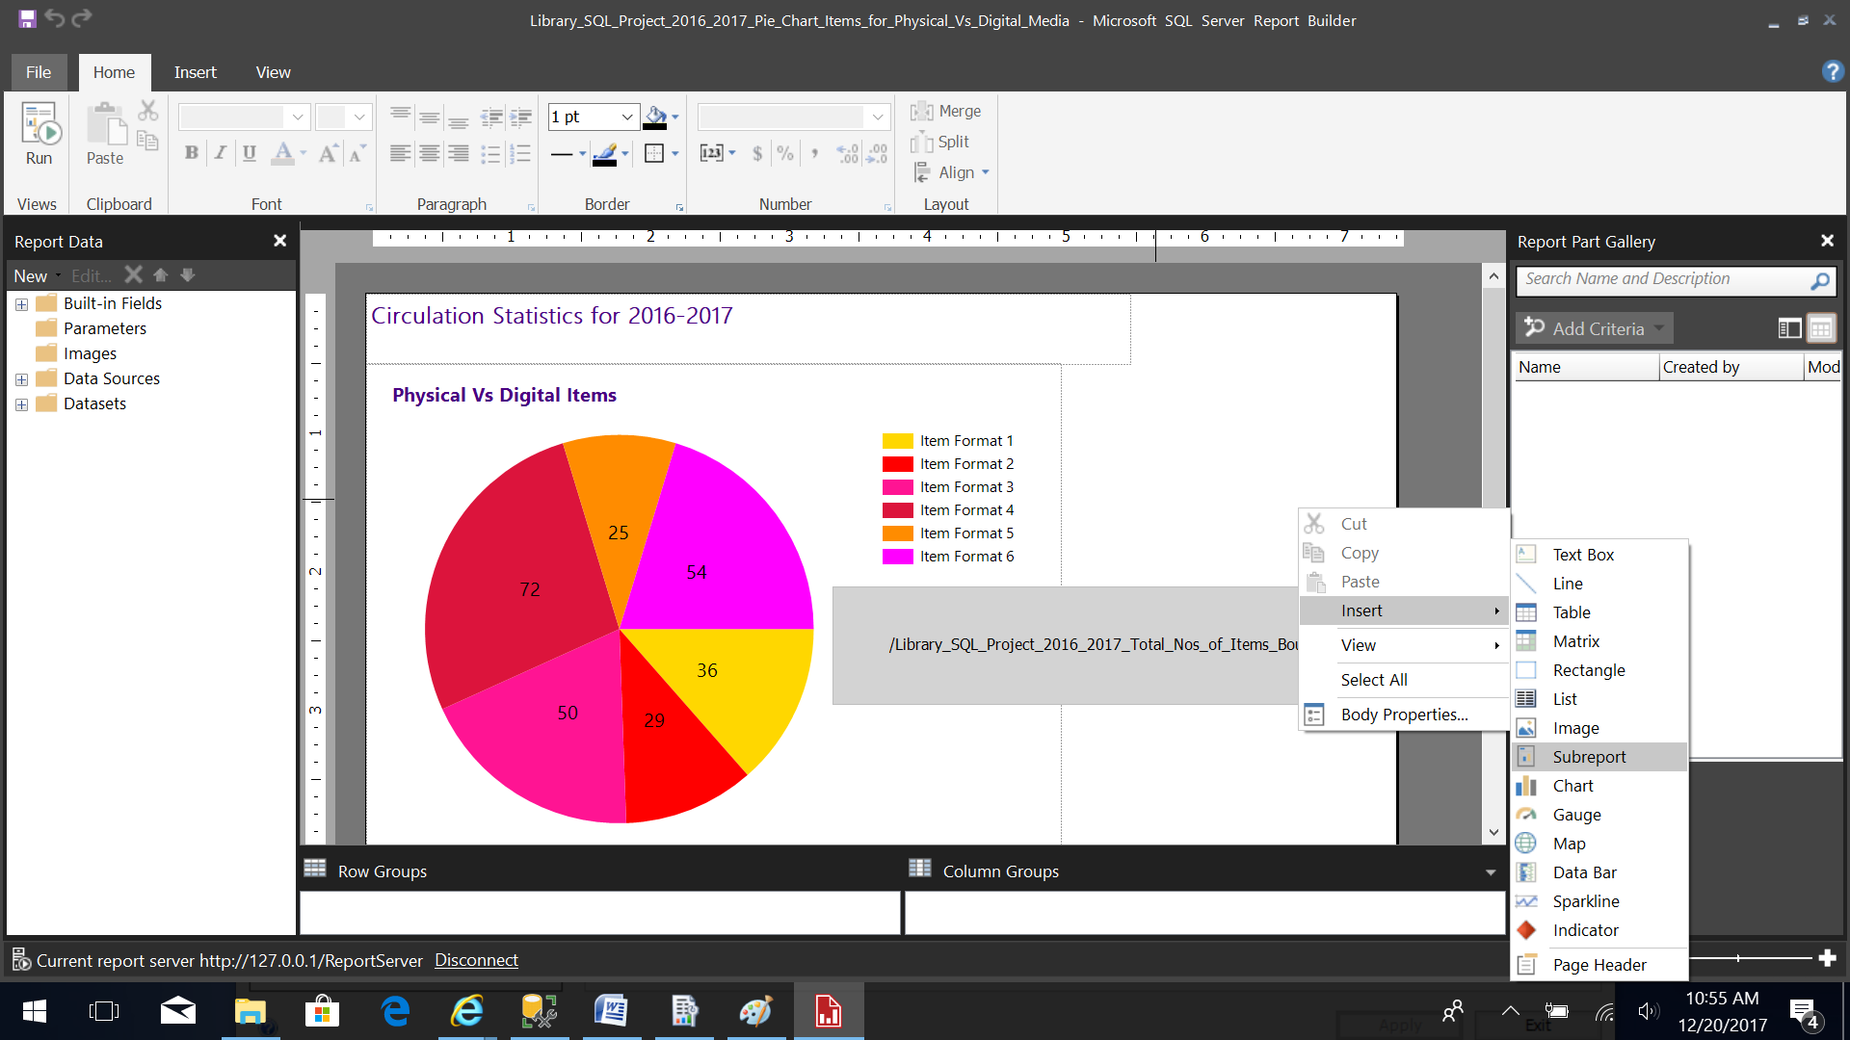
2. Click on the “Browse” button to use this report as sub-report. Then click “OK”. 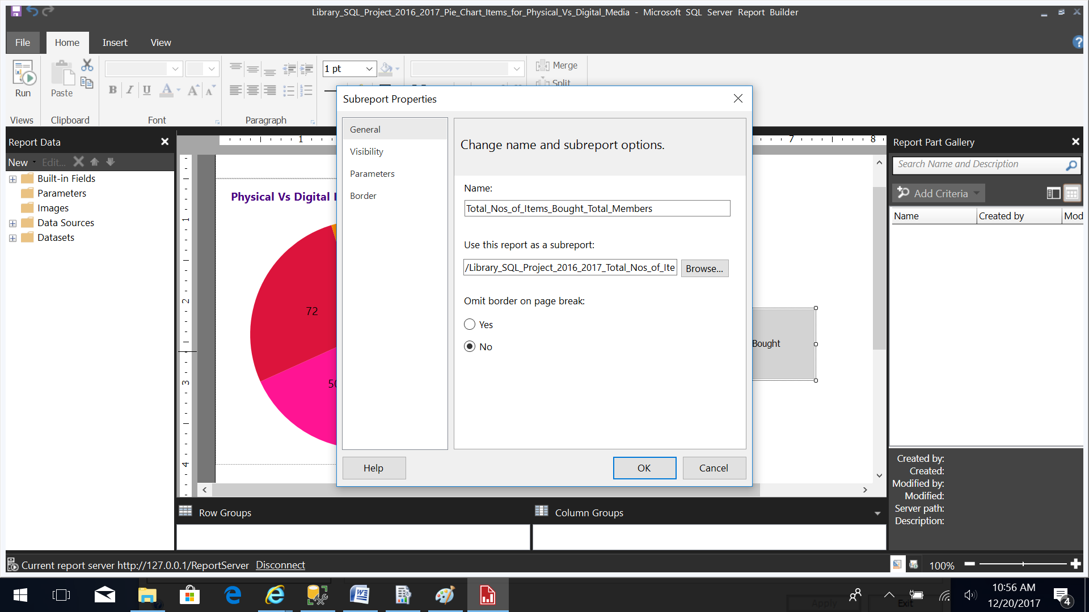
3. The Data Labels can be made visible by right-clicking on the chart and selecting the “Show Data Labels” option. 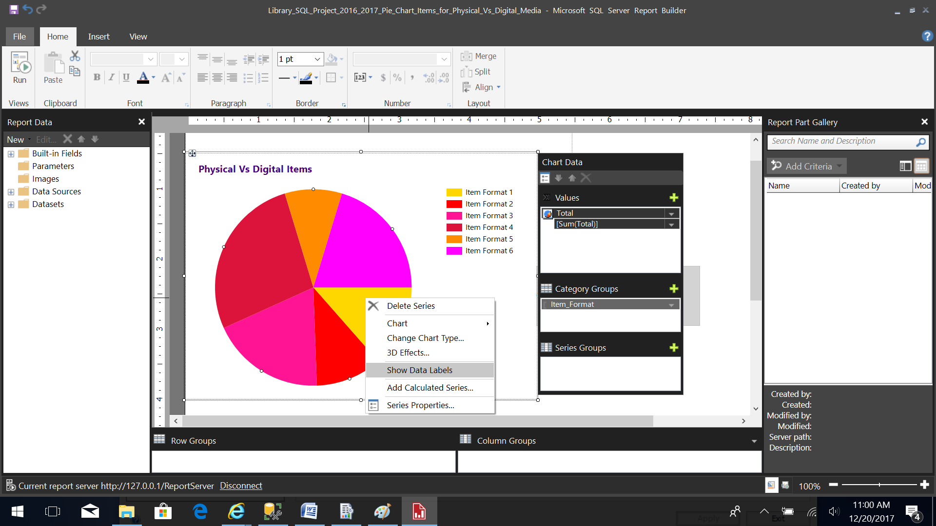
4. Click on “Run” report button to run this report. 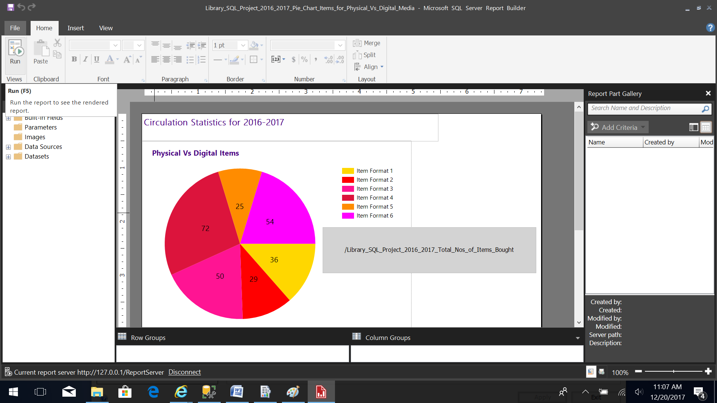
5. Here the report and the embedded sub-report can be seen. Click on “Design” button or use F8 key to go back to the report editing screen. 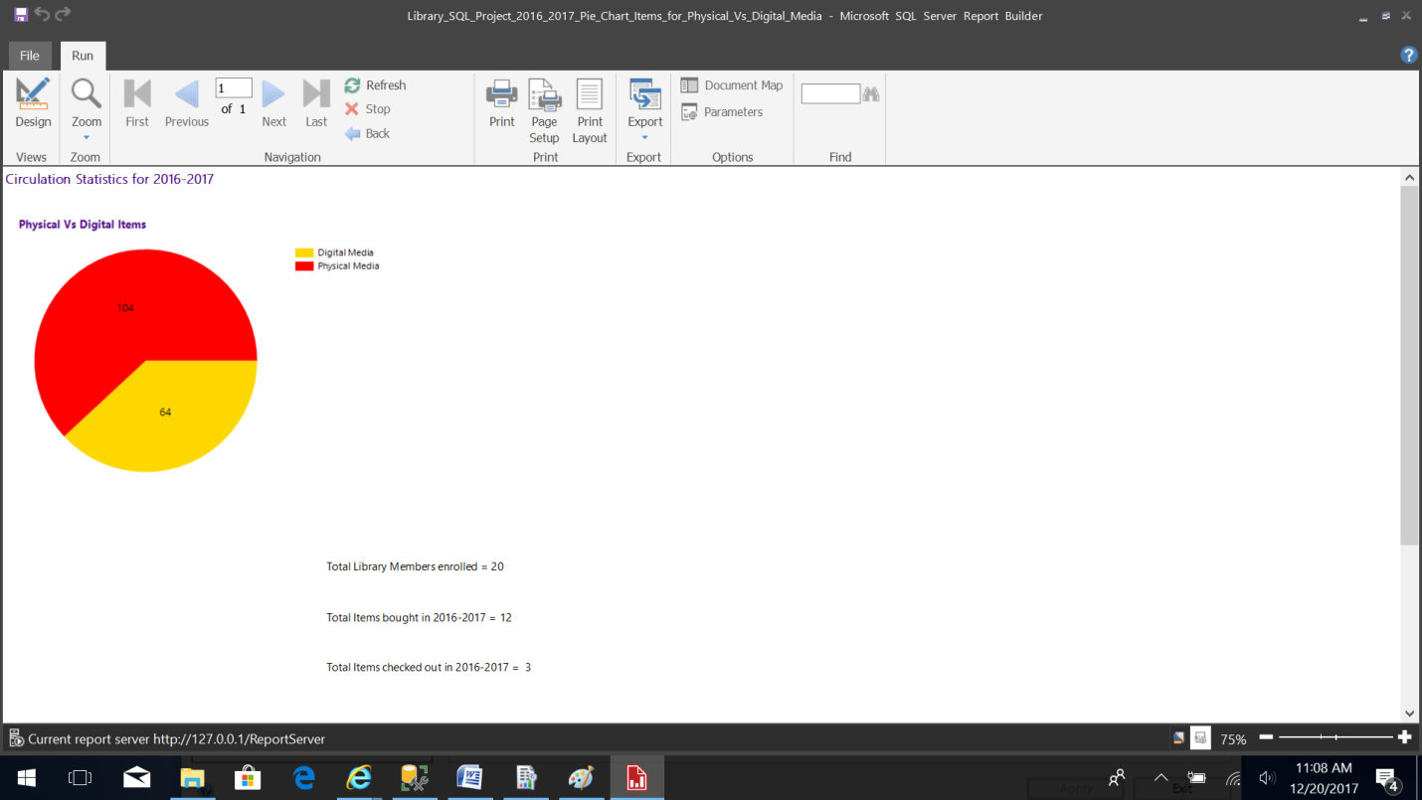
6. Click on “File” button and select “Publish Reports Parts” to publish the report. 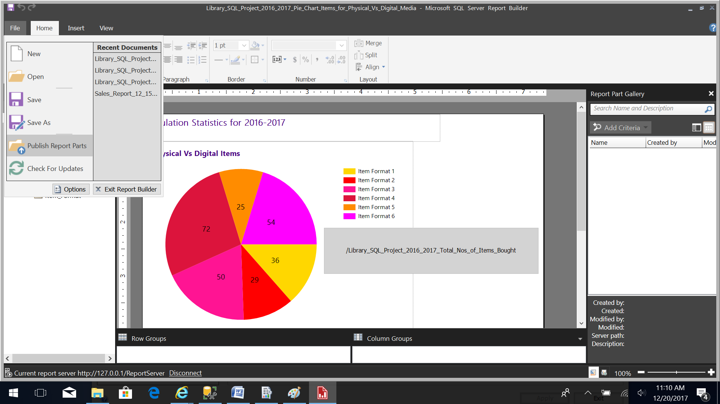
7. Select “Publish all report parts with default settings” to publish the report to the server. 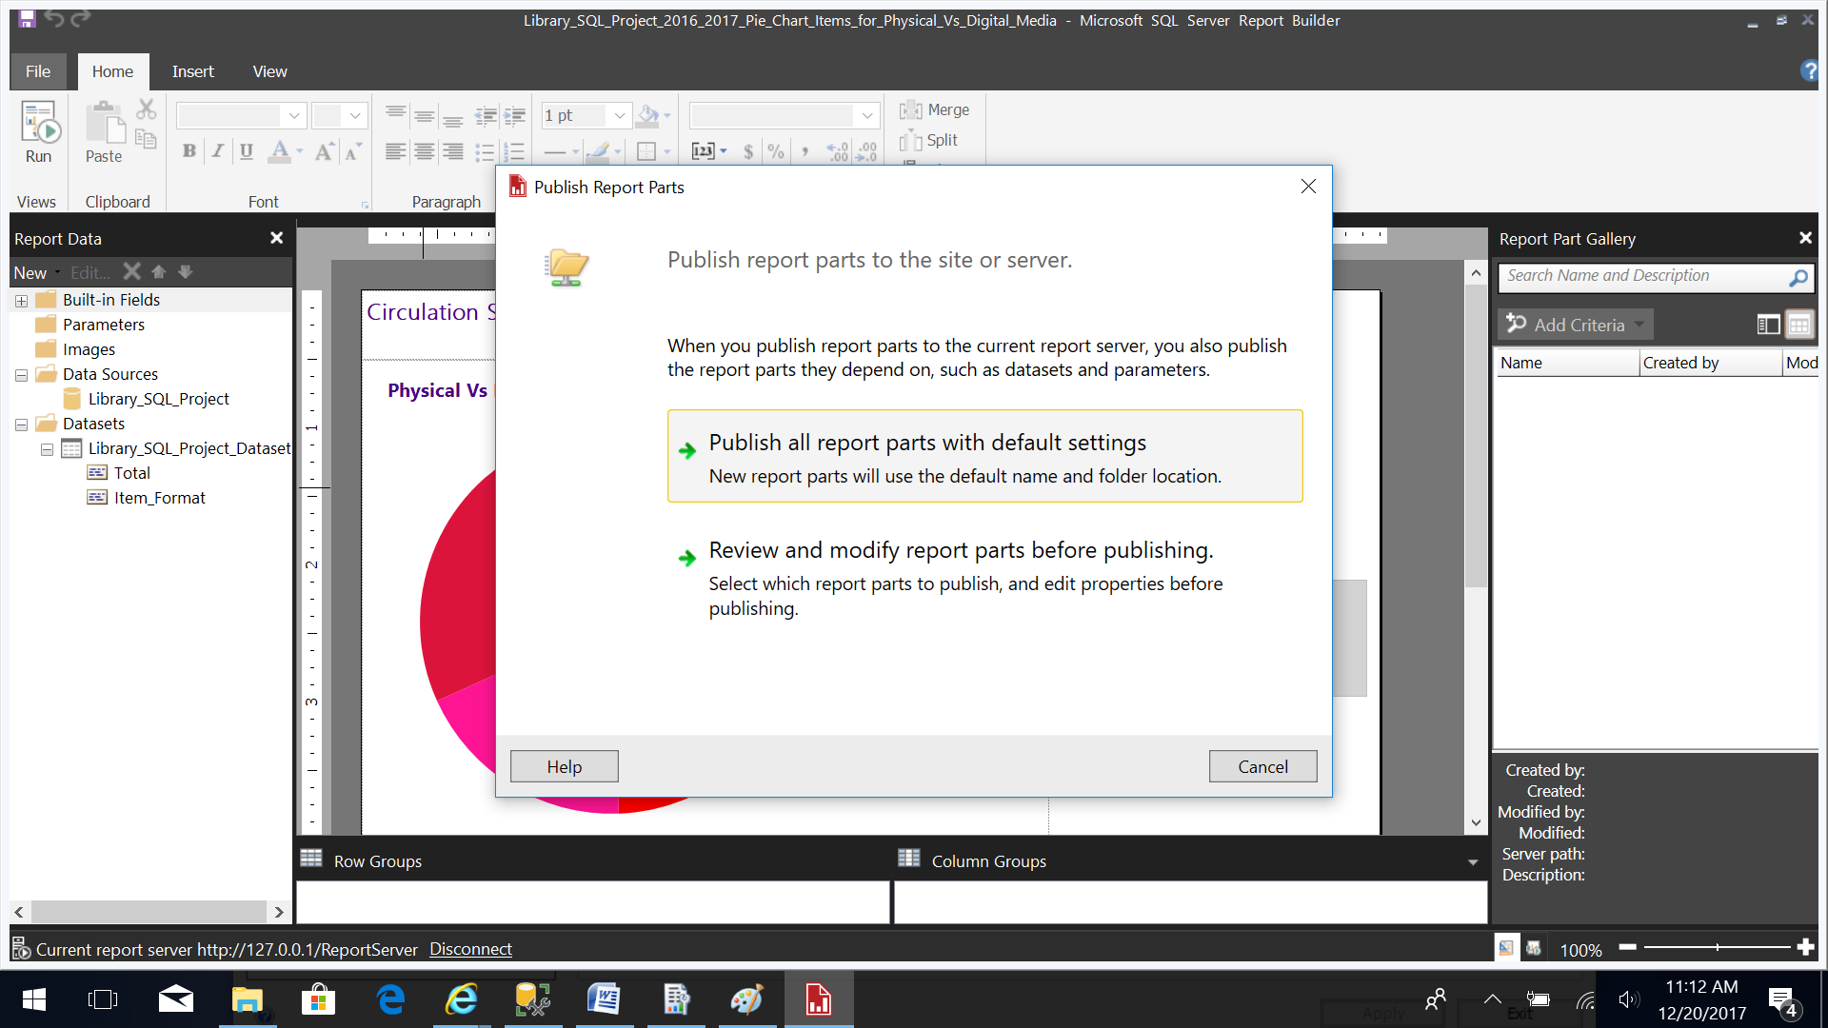
8. A message is displayed with the publish status for report parts and reports. 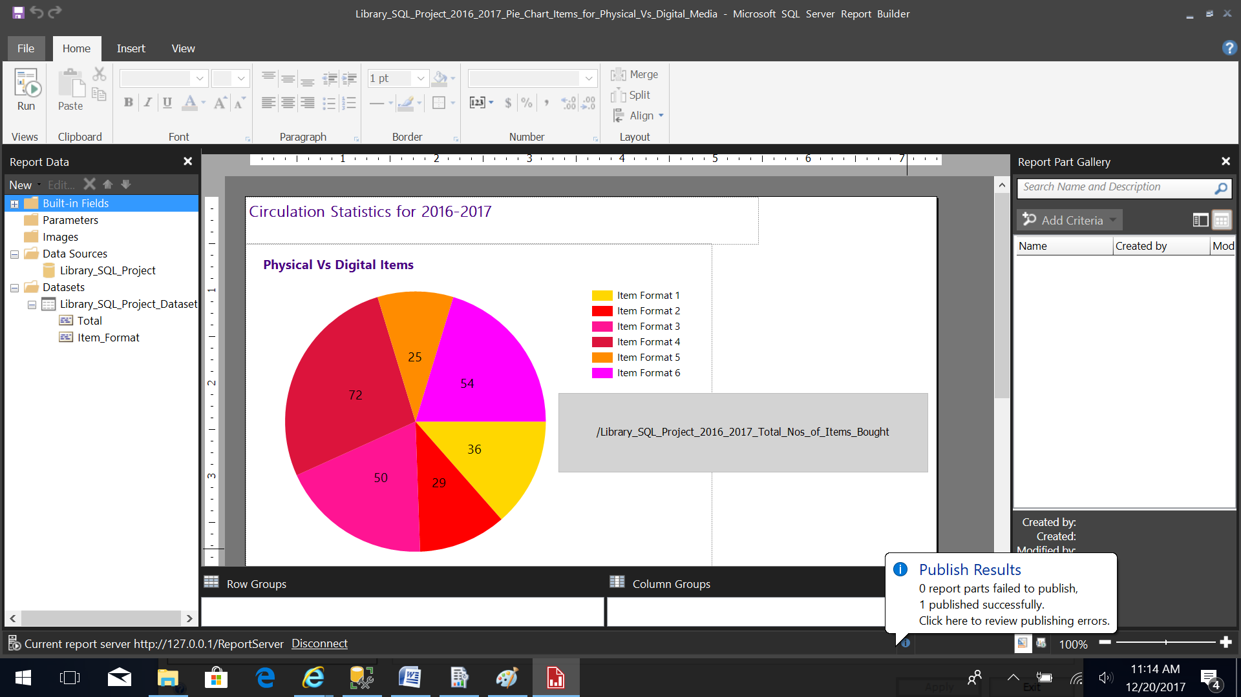
9. Select the message to view detailed description. Here you can edit the description of the report parts and then re-publish as required. 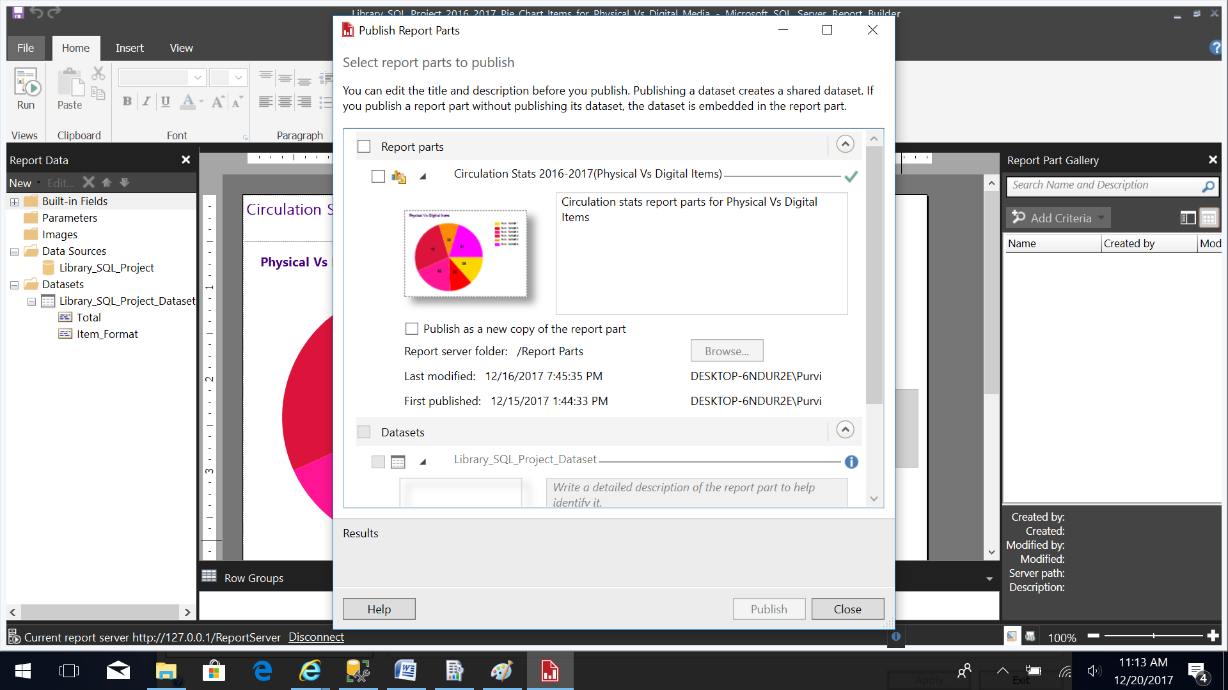
10. The report can be run and downloaded as a .pdf file or word document for standalone access. 